Curriculum vitae

Software Developer

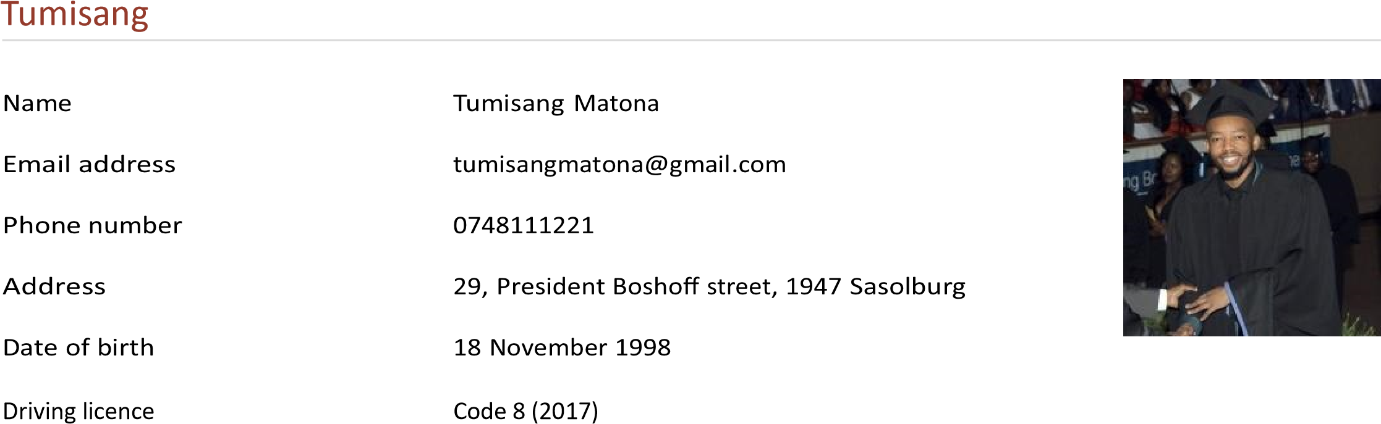

|  |  |
| --- | --- |
| Gender | Male |
| Nationality | South African |
| LinkedIn | linkedin.com/in/tumisang-matona-46289a205 |
| TECHNICAL SKILLS - | • Programming Languages: C#, .NET, Java, SQL |
| • Software | Microsoft Office Suite, Microsoft 365, Team Viewer • Operating Systems: Windows XP, 7, 8, 10, 11 |
| • Networking | Router Configuration, Fibre Network Coverage |
| • Web Development | HTML, CSS, JavaScript |
| • Systems Administration | Installation, Maintenance, Troubleshooting, Customer Service Environments |
| JOB COMPENTENCIES  • Attention to Detail: | • Action Oriented: Proactively addresses technical challenges and resolves issues in a timely manner.  Ensures accuracy and precision in all tasks and deliverables. |
| • Technical Savvy: | Possesses advanced technical knowledge and adapts quickly to new technologies and tools. |
| • Customer Oriented:  Profile | Demonstrates a strong commitment to understanding and meeting customer needs, providing exceptional service and support. |

I am a young and passionate Information Technology graduate, who strives for greatness and experience of one’s full potential in the industry. My journey in the world of technology began with a curiosity for how things work and I enjoy exploring the latest advancements in technology, honing my skills through continuous learning, and finding inspiration in the world around me.

# Education

Jan 2012 - Nov 2016 National Senior Certificate

HTS Sasolburg, Sasolburg

Feb 2017 - Feb 2022 National Diploma in Information Technology

Central University of Technology, Bloemfontein Software

Development

* Software Development I, II, III
* Software Engineering, I, II, III
* Web Content Management I, II, III
* Internet Programmer I
* Information Technology Essentials I
* Academic Literacy and Communication Studies I, II
* Database I, II
* Graphic Design I, II, III

Employment

Jul 2022 - Jul 2024 IT Intern

CTE Engineering, Sasolburg

Providing Technical Support

Customer Services

Technical and Desktop customer service experience

Installation of Network Systems

Hardware and Software maintenance

Problem solving

Equipment repairs

IT User Support

Maintain Desktop systems

Router Configuration

Troubleshooting

# Skills

Work ethic Very good

Excellent

Teamwork (working in multidisciplinary teams)

Very good

Proactive and ability to multi-task on all levels

Excellent communication Very good

Excellent

Interpersonal, time management and organisational skill

Very good

Ability to follow through on instructions

# Languages

|  |  |
| --- | --- |
| English  Sesotho | Fluent  Fluent |
| Afrikaans Certificates | Moderate |
| Jan 2024  References | Introduction to Cybersecurity  Cisco NetAcad |

Jonas Lehoko

CTE Engineering, Sasolburg

0722636100, CTEENGINEERING8@GMAIL.COM

Maletsatsi Matona

NACOSA, Kimberly

0796134258, Matonamj@gmail.com

Prince Thoka

Free State Department of Education, Sasolburg

0661295155, Princethoka@gmail.com